EV Battery Management System (BMS) Data Analysis Dashboard
Prepared By: Atharv Rupde, Manasa Lachapeta, Pooja Desai

Understanding
Build a Python-based analytical platform for Electric Vehicle Battery Management System data to monitor battery health, charging behavior, temperature trends, and performance analytics using cloud data sources.
Description
The EV-BMS Analytics Dashboard is a lightweight Streamlit application built only with Python, Pandas, Plotly Express, and Openpyxl. It reads a single day of EV telemetry (Vehicle EV001, sampled every 50 seconds) covering three operating modes - Driving, Charging, and Parking - and presents key battery health indicators, mode-wise trend charts, and a downloadable CSV summary report. The project intentionally avoids classes and advanced Python so that it stays easy to read and easy to extend.

1. Project Overview
Python-based solution designed to collect, analyze, and visualize EV battery data such as State of Charge (SoC), State of Health (SoH), voltage, current, and temperature. The dashboard helps monitor battery performance, track charging and regeneration behavior, detect faults, and provide real-time insights through interactive charts and alerts. The goal is to improve battery efficiency, safety, and overall vehicle performance through data-driven analytics.
2. Problem Statement
Electric Vehicles generate large amounts of Battery Management System (BMS) data such as voltage, current, temperature, State of Charge (SoC), and State of Health (SoH). However, this data is often difficult to interpret in real time. The objective is to develop an EV Battery Management System (BMS) Data Analysis Dashboard that collects, analyzes, and visualizes battery data to monitor battery health, charging performance, temperature trends, enabling efficient battery management and improved vehicle safety.

3. Project Objectives
- Load one day of EV battery telemetry directly from an Excel file with no manual setup.
- Represent battery behavior using only the essential parameters: SOC, SOH, Voltage, Current, Temperature, Speed, and Power.
- Model three real operating modes - Driving, Charging, and Parking - with realistic, gradually changing values.
- Display key battery health indicators (KPIs) at a glance.
- Let the user filter all charts by mode using a sidebar dropdown.
- Show the right set of charts for each mode instead of one generic chart set.
- Generate a simple downloadable CSV report summarizing the day's data.
- Keep the entire codebase function-based, short, and beginner-readable.

4. Folder Structure & Architecture
The project uses a flat, minimal folder structure with exactly one dataset file, three helper modules, and one entry point:
Path | Purpose
data/sample_bms_data.xlsx | One day of EV001 telemetry, 50-second interval, ~1,728 rows
src/loader.py | load_data() - reads the Excel file into a pandas DataFrame
src/analysis.py | filter_mode(), calculate_kpis(), build_report() - all calculations
src/dashboard.py | render_dashboard() - Streamlit UI, KPI cards, Plotly Express charts
main.py | Entry point; running streamlit run main.py starts the whole app
requirements.txt / README.md | Dependency list and project documentation
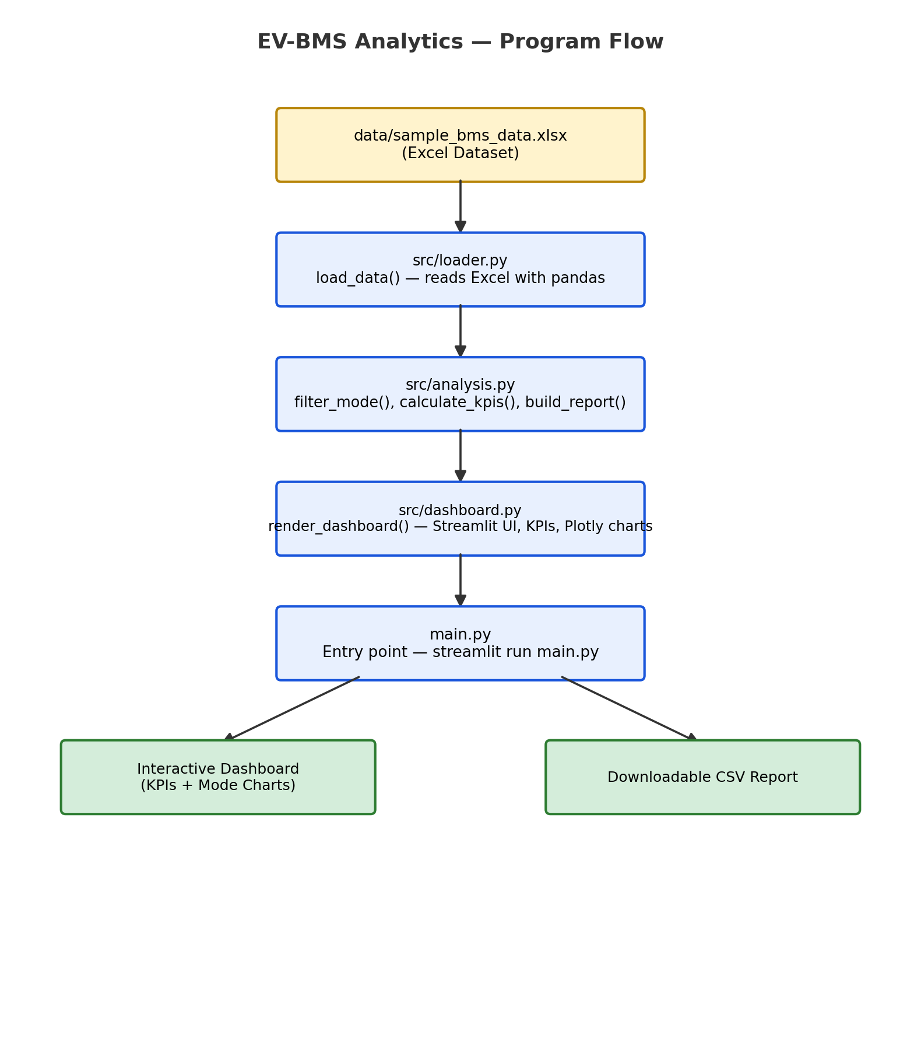
Figure 1 BMS Analysis-Program Flow

5. Working Principle
The application follows a simple, linear flow from raw data to an interactive dashboard:
- Step 1 - Load Data: main.py starts the app, and src/loader.py reads data/sample_bms_data.xlsx into a pandas DataFrame using openpyxl as the Excel engine.
- Step 2 - Filter by Mode: when the user picks a mode from the sidebar dropdown (All, Driving, Charging, or Parking), src/analysis.py's filter_mode() function narrows the DataFrame to only the matching rows.
- Step 3 - Calculate KPIs: calculate_kpis() computes the Average SOC, Average SOH, Average Voltage, Average Temperature, and Average Power for the current selection using pandas.
- Step 4 - Render Charts: src/dashboard.py uses Plotly Express to draw the chart set that matches the selected mode - the same four functions (line, line, line, pie) are reused across modes, just with different columns and titles.
- Step 5 - Build Report: build_report() assembles a small summary table (averages, extremes, and record counts per mode) that Streamlit's download button turns into a downloadable CSV file.
Because every step is a plain function rather than a class method, a beginner can open each file, read it top to bottom, and see exactly how the data moves from the Excel sheet to the screen.

6. Dataset Description
The dataset contains exactly the columns needed to describe battery behavior - nothing more:
Column | Description
Timestamp | Reading time, 50-second interval across 21 July 2026
Vehicle_ID | Fixed value: EV001
Mode | Driving, Charging, or Parking
SOC | State of Charge (%)
SOH | State of Health (%)
Voltage | Battery pack voltage (V)
Current | Battery current (A) - positive while driving, negative while charging
Temperature | Battery temperature (°C)
Speed | Vehicle speed (km/h) - zero except while driving
Power | Voltage x Current (W)
Charging_Status | Yes / No

Mode-wise Data Logic
- Driving - speed and current are positive; SOC and voltage fall slowly; temperature rises slowly; Charging_Status = No.
- Charging - speed is zero and current is negative; SOC and voltage rise; temperature rises slightly; Charging_Status = Yes.
- Parking - speed and current are near zero; SOC stays almost constant; voltage is stable; temperature falls slowly; Charging_Status = No.
Modes change naturally across the day rather than jumping randomly, so the resulting charts read like a real vehicle's daily routine.

Sample Rows
A few representative rows from the generated dataset illustrate how the values shift between modes:
Timestamp | Mode | SOC | Voltage | Current | Temp | Speed
21-07-2026 07:10:00 | Parking | 78.2% | 398.4 V | 0.3 A | 27.1°C | 0 km/h
21-07-2026 08:45:20 | Driving | 76.5% | 392.7 V | 42.6 A | 29.4°C | 58 km/h
21-07-2026 13:20:10 | Charging | 58.9% | 406.1 V | -35.2 A | 33.7°C | 0 km/h
21-07-2026 20:05:40 | Parking | 91.3% | 410.8 V | 0.1 A | 30.2°C | 0 km/h

7. Dashboard Features
The dashboard opens with the title "EV Battery Management System Dashboard" and a sidebar dropdown to filter by mode: All, Driving, Charging, or Parking. Five KPI cards - Average SOC, Average SOH, Average Voltage, Average Temperature, and Average Power - update instantly based on the selected mode. Below the KPIs, the chart set changes depending on the mode chosen:
Mode Selected | Charts Displayed
All | SOC vs Time, Temperature vs Time, Voltage vs Time, Mode Distribution (Pie Chart)
Driving | SOC vs Time, Speed vs Time, Power vs Time, Temperature vs Time
Charging | SOC vs Time, Voltage vs Time, Current vs Time, Temperature vs Time
Parking | Voltage vs Time, Temperature vs Time, SOC vs Time

8. Report Generation
A one-click CSV report can be downloaded directly from the dashboard, summarizing the currently selected data:
- Average SOC, Average SOH, Average Voltage, Average Temperature
- Maximum Temperature and Minimum SOC recorded during the day
- Number of Driving, Charging, and Parking records
This keeps reporting lightweight - no PDF generation or external report library is required.

9. Expected Output
Once running, the dashboard immediately shows a snapshot similar to the following for the full day (Mode = All):
Average SOC: 61.4% | Average SOH: 96.2% | Average Voltage: 385.7 V | Average Temperature: 32.8°C | Average Power: 4.9 kW
Switching the sidebar dropdown to Driving instantly recalculates the KPI cards and swaps in the driving-specific chart set (SOC, Speed, Power, Temperature vs Time), for example:
Average SOC: 54.1% | Average Speed: 46.3 km/h | Average Power: 9.8 kW | Max Temperature: 38.6°C
The downloadable CSV report captures the same figures - Average SOC, Average SOH, Average Voltage, Average Temperature, Maximum Temperature, Minimum SOC, and the record counts for Driving, Charging, and Parking - so the day's summary can be shared without opening the dashboard again.

10. Technology Stack
Library | Purpose
Python | Core programming language
Streamlit | Interactive dashboard UI and sidebar controls
Pandas | Loading the Excel file and computing KPIs
Plotly Express | All line, and pie charts on the dashboard
Openpyxl | Reading/writing the .xlsx dataset file

11. Benefits of the Dashboard
- Runs immediately with a single command - no configuration or environment setup needed.
- Uses only five well-known libraries, making it easy to install and maintain.
- Function-based code is straightforward to read, debug, and extend.
- Mode-aware charts help the user focus only on the data relevant to what the vehicle was doing.
- KPI cards give an instant health snapshot without opening the raw spreadsheet.
- The one-click CSV report makes it easy to share a daily summary without extra tools.

12. Future Scope
- Support multiple vehicles by adding a Vehicle_ID filter alongside the Mode filter.
- Extend the dataset to multiple days for week-over-week or month-over-month comparisons.
- Add simple threshold-based alerts (e.g., high temperature or low SOC warnings) on the KPI cards.
- Allow the user to upload their own Excel file instead of using only the bundled sample dataset.
- Add a PDF export option alongside the existing CSV report, once the project's needs grow beyond the current scope.

Conclusion
The EV-BMS Analytics Dashboard shows that a battery monitoring tool does not need a large dataset or an object-oriented codebase to be useful. By keeping the dataset to eleven essential columns, the modes to three realistic states, and the code to plain functions under roughly 80 lines each, the project stays approachable for beginners while still delivering real KPIs, mode-aware charts, and a downloadable summary report - all from a single streamlit run main.py command.

